# ORGANIZATION THEORY

# ASSESSMENT 2

# CASE STUDY

Contents

ORGANIZATION THEORY 1

ASSESSMENT 2 1

CASE STUDY 1

Examination of Google's Hierarchical structure in Accomplishing its Central goal and Vision statements 4

Introduction 4

Capabilities and Products 4

There are no Low levels of middle management between leadership and employees. 4

Receptiveness and Development Culture 5

Reflection of intelligence and excellence 5

Comfortable and socially conscious environment 5

Critical Ability for Business Development 5

Organisation and Culture: Synergies 6

Competencies in Human Resources 6

SWOT Examination and Brand image 6

Global Impact 6

Accentuation on advancement and development 7

Adaptability and flexibility 7

Utilising Advancement and Coordinated effort 7

Client-Driven Strategy 7

Risk-Taking and Capacity to Bear Disappointment 8

Social and Ecological Responsibility 8

Overseeing Dynamic Cycles for Development and Advancement at Google 8

Inventiveness and Challenge 8

Way forward to deal with the leadership style 8

Google's ongoing development 9

Offering Free, Precise, and Fair Admittance to Data 9

Worldwide Effect and Responsiveness 9

Vision and Development 9

Innovative Culture and 20% Time Rule 10

Acquisitions and Strategic Partnerships 10

Input Circle and Client-Driven Approach 10

Direction Driven by Information 10

Research and development 10

Corporate Social Responsibility (CSR) Initiatives 10

Change in accordance with Alterations in Guidelines 11

Drives for Variety and Consideration 11

Ceaseless Ability Advancement 11

Conclusion 11

References 12

# 

# Examination of Google's Hierarchical structure in Accomplishing its Central goal and Vision statements

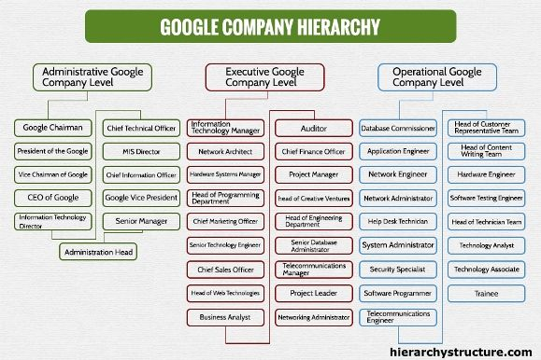

(Pinterest, 2023)

## Introduction

The organisation's overall exercises are directed by Google's vision statement, "to give admittance to the world's data in a single click (Nielson and Gandor, 2022)," and statement of purpose, "to coordinate the world's data and make it accessible and helpful (Octaberlina et al., 2020). We will look at the characteristics and factors that affect Google's hierarchical structure as per its objective and vision proclamations in this case study.

## Capabilities and Products

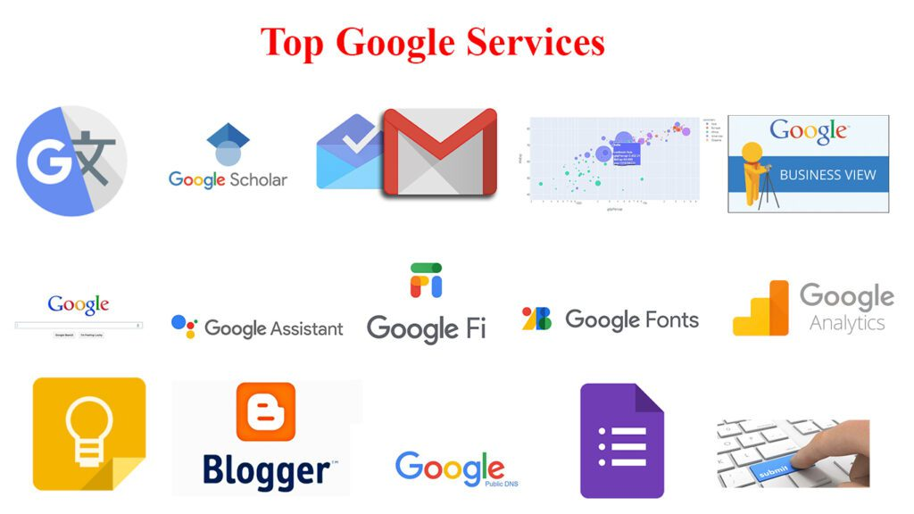

(Vijay, 2022)

Products and capability-based definitions are combined in Google's cross-functional hierarchical design (Frank et al., 2022). A methodological approach to achieving the objective is demonstrated by using product categories, such as Pixel devices, and company roles, such as Sales Operations, Engineering and design, and Product Management, as the foundation for personnel groupings (Wang et al., 2022). Google guarantees an engaged and concentrated labour force by organising groups around capabilities and items, which assists with putting together the world's data effectively

## There are no Low levels of middle management between leadership and employees.

One thing to see about Google's authoritative design is the few to no level of middle management between leadership and employees (Wilson, 2020). This low-ordered progression energises the executives, teams, and staff to communicate successfully with each other. By lessening administrative obstacles, this level of authoritative design helps in making information broadly open and accessible to everyone. The organisation's capacity to arrange data universally is facilitated by the simplicity with which staff might divide data between themselves (Van der Voort et al., 2021).

## Receptiveness and Development Culture

The innovative and receptive corporate culture of Google is fundamental for the organisation's outcome in understanding its objectives (Gong et al., 2022). The level of authoritative design works the open trade of thoughts and feelings among representatives. The objective of the mission, which is to make it possible for everyone to access information, is met by this transparency (Cui, 2021). By encouraging staff members to submit ideas, the creative culture also encourages originality and supports the goal of worldwide one-click access to information.

## Reflection of intelligence and excellence

Google's objective is to make valuable knowledge, which aligns with the company's emphasis on intelligence and excellence (Shao et al., 2022). The organisational structure encourages employees to strive for excellence, particularly in the development of internet services and consumer electronics (Akdere and Erkan, 2020). Participating effectively in drives and trials shows a devotion to a certifiable application, which is the reason for conveying high-quality and realistic information.

## Comfortable and socially conscious environment

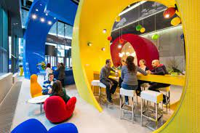

(Rossi, 2015)

The hierarchical culture of Google maintains a comfortable, inviting, and socially conscious independent venture feel (Gadinis and Miazad, 2020). This environment supports the organisation's capacity to proficiently deal with the world's data, which encourages representative fulfilment and data trade. The drawn-out objective of empowering a single tick admittance to data is upheld by familial compatibility, which encourages cooperation and inspiration among representatives.

## Critical Ability for Business Development

One of the principal supporters of the advancement of abilities expected for corporate development is Google's authoritative construction (Chai and Zu, 2021). The association may decisively disseminate assets and abilities across numerous exercises and product offerings on account of the cross-functional methodology. Google's capacity to deal with the difficulties given by worldwide contenders like Apple, Samsung, Amazon.com, and others is guaranteed by its essential capability. The construction's innate adaptability assists the business with accomplishing its objectives by setting it up for long-haul development.

## Organisation and Culture: Synergies

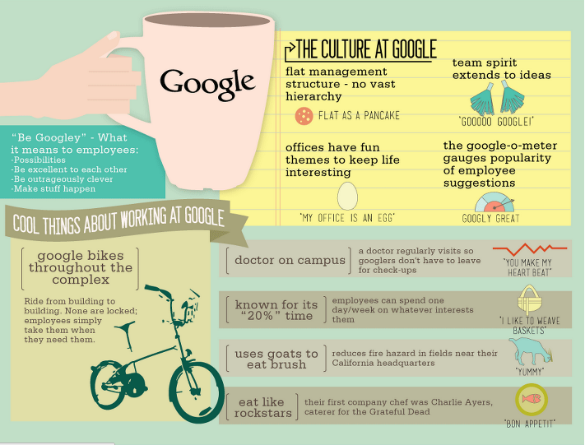

(Jackson, 2013)

Google's organisational structure and culture work so well together that they work together to strengthen one another. The flat hierarchical construction works out in a good way for the imaginative and open culture, empowering a work climate where staff individuals go ahead and propose new ideas (Cardiff et al., 2020). This sort of collaboration is fundamental to satisfying the point of giving widespread admittance to significant data since it cultivates a dynamic, helpful way to deal with critical thinking and development.

## Competencies in Human Resources

The alignment of structure and culture fosters human resource competencies that are necessary for business expansion. The capabilities and capacities of Google's staff are essential to the organisation's outcome in sorting out the world's data (Marion and Fixon, 2021). The flat organisational structure helps build a staff with a lot of talent and drive. It also makes it easier for people to talk to each other, work together, and share knowledge. These skills are necessary for Google to fulfil its business mission and vision statements.

## SWOT Examination and Brand image

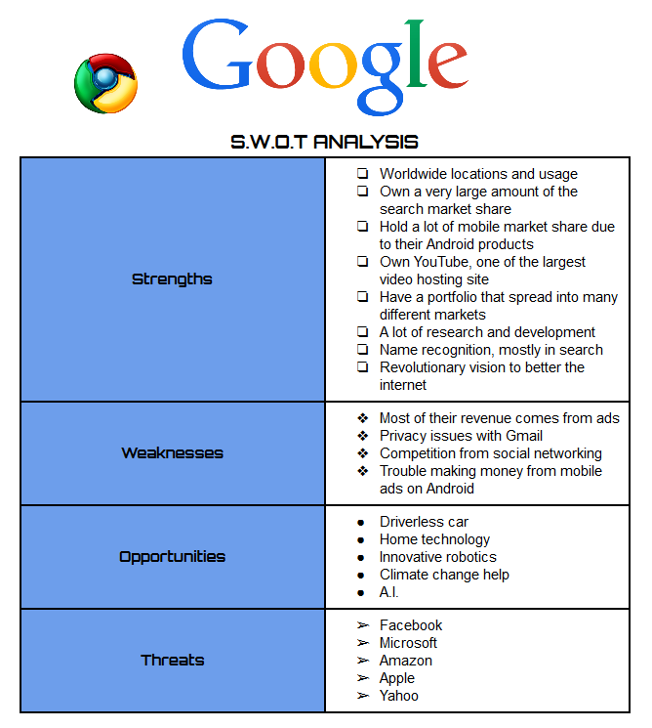

(saidivij5816, 2015)

The organisation's brand image is supported by the imaginative culture that penetrates Google's hierarchical design. The brand is well-regarded in view of the emphasis on intelligence and knowledge. By drawing clients and partners, this brand image — which the SWOT investigation featured as a strength — upholds the reason by expanding the helpfulness and accessibility of the material organised by Google (Leul et al., 2023).

## Global Impact

Google's organisational structure has played a role in the company's ability to dominate the global market for consumer goods, internet services, and information technology (Gawer, 2022). The organisation's ability to adjust its authoritative construction to suit different business sectors and geological regions advances worldwide impact. This adaptability is critical to accomplishing the objective of giving individuals from one side of the planet to the other a single tick admittance to data while considering their shifted necessities and inclinations.

## Accentuation on advancement and development

The way of life of consistent innovation and advancement is energised by Google's corporate construction (Do et al., 2022). The accentuation of open correspondence channels and cross-practical groups inspires staff individuals to ceaselessly search for better approaches to take care of issues and add to the production of state-of-the-art innovations (Mier and Kohli, 2021). This accentuation on development is in accordance with Google's plan to empower a single tick admittance to data and its motivation to sort out information productively.

## Adaptability and flexibility

Google's level hierarchical design makes it adaptable, which makes it simpler to adjust rapidly to new advancements and changing economic situations (Hanelt et al., 2021). Being versatile is pivotal for Google's capacity to achieve its targets and stay ahead of the reliably changing information development industry. Having the flexibility to change plans and cycles quickly achieves the excessively long target of working with comprehensive permission to access information.

## Utilising Advancement and Coordinated effort

Google's legitimate plan uses development to enable workers in different regions to collaborate. The fuse of cooperative stages and instruments, which makes it simpler to arrange data and make it available around the world, upholds the organisation's objective (Femhi and Samuel, 2022). Since it is fundamental for the acknowledgement of the single tick access vision, which is subject to proficient coordination and correspondence, this viewpoint is incredibly huge.

## Client-Driven Strategy

A client-driven strategy that permeates the structure of the company has an impact on Google's hierarchical culture. The organisation urges its representatives to appreciate and address client prerequisites effectively. The target of making information extensively significant and accessible is recognised by and extensively utilising this client-focused approach. The hierarchical design upholds this technique and empowers groups to keep up with client concentration and responsiveness inside their particular jobs and product offerings.

## Risk-Taking and Capacity to Bear Disappointment

The hierarchical design at Google advances a culture of proceeding with carefully weighed-out courses of action and being willing to come up short. It fosters a creatively stimulating workplace because employees are encouraged to try new things and take calculated risks. This part is essential to understanding the organisation's objectives since it cultivates a demeanour that invites hardships and searches for novel approaches to orchestrate and make data open effectively.

## Social and Ecological Responsibility

Google integrates social and ecological obligations into their hierarchical plan. The organisation's level of commitment to making information supportive and open to everything is in accordance with its devotion to maintainability and corporate social obligation. With regards to the organisation's central goal, the hierarchical construction elevates endeavours relating to maintainability and moral corporate lead, assisting with having a gainful overall impact.

# Overseeing Dynamic Cycles for Development and Advancement at Google

In their letter to planned investors, Google's originators, Larry Page and Sergey Brin, underlined that their firm isn't and won't turn into a customary one. This guarantee features the unmistakable technique Google has used to deal with the unique elements that impact its turn of events and extension. We should look at Google's proficient treatment of these liquid cycles:

## Inventiveness and Challenge

A vital part of Google's administration style is the organisation's commitment to advancing a climate that values imagination and challenge. This accentuation rouses workers to think inventively, take on new assignments, and innovate constantly. Google can stay on the ball by acclimating to recent fads, advancements, and client assumptions because of this methodology, which is in accordance with the quick-moving nature of the innovation area.

## Way forward to deal with the leadership style

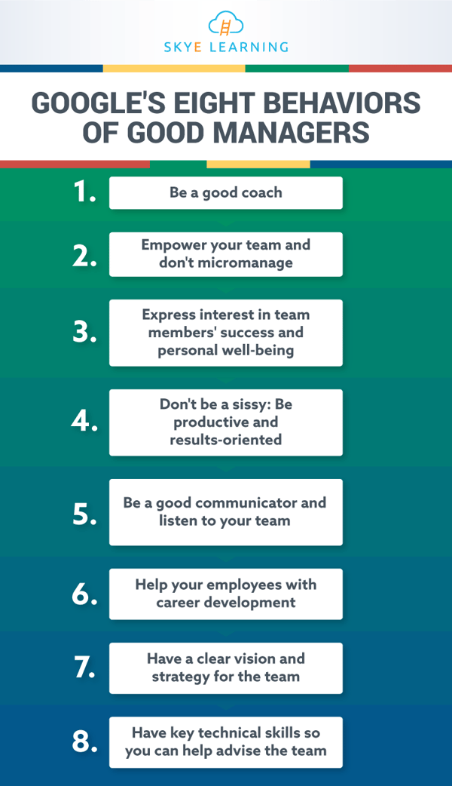

(Skye Learning Team, 2019)

As expressed plainly by the originators, Google is certainly not a conventional business. This irregular technique likewise applies to the administration style, which is characterised by a level hierarchical design and a cooperative, open, and imaginative culture. Due to its uncommon authoritative design, Google can act rapidly because of chances and changes in the business. It likewise considers adaptability and spryness in direction.

## Google's ongoing development

A flexible and agile corporate strategy has characterised Google's ongoing development as a privately held corporation. Unlike numerous organisations, Google has stayed liberated from the transient requests of quarterly income assumptions to focus on long-haul goals, trial and error, and chance-taking (Mier and Kohli, 2021). Because of its absence of prompt market pressure, Google has had the option to put resources into enormous-scope projects, research state-of-the-art innovation, and usually direct its development.

## Offering Free, Precise, and Fair Admittance to Data

The organisation's originators accentuate Google's commitment to give fair-minded, honest, and sans-cost admittance to data. This responsibility includes continuous algorithmic changes, progressions in search innovation, and missions to disperse bogus data. It is a unique cycle all by itself. Collaborations to raise content quality and accessibility, continuous enhancements to the search algorithm, and the development of novel technologies like artificial intelligence are all part of Google's strategy.

## Worldwide Effect and Responsiveness

Confinement drives, worldwide development, and item and administration transformations to different business sectors feature Google's responsiveness to the dynamic and fluctuating worldwide scene. Google's acknowledgement of its worldwide effect is apparent in the explanation. A commitment to comprehending and meeting the diverse requirements of users worldwide is one of the company's dynamic processes.

## Vision and Development

A drawn-out vision coordinates Google's treatment of dynamic cycles. The organisation is notable for its daring drives, which incorporate web-radiating inflatables and self-driving vehicles. Google's willingness to fund projects that may take several years to complete is demonstrated by these initiatives. Google's drawn-out vision adds to its ceaseless development and advancement by empowering it to impact how innovation and data openness are created from now on.

## Innovative Culture and 20% Time Rule

Google advances a climate where staff individuals are permitted to try and work on their thoughts. Representatives are allowed to commit a piece of their functioning hours to independent ventures under the notable "20% time" rule (Molotsi et al., 2023). This gives employees the freedom to explore novel concepts that help Google grow and foster creativity within the organisation.

## Acquisitions and Strategic Partnerships

In order to remain at the forefront of technology, Google makes strategic use of acquisitions and partnerships. The business has a history of securing state-of-the-art new companies and banding together with another essential part of the tech business. This creative system impacts Google's development direction by aiding the joining of new thoughts, abilities, and innovation into its environment.

## Input Circle and Client-Driven Approach

Google keeps on focusing on the client experience. The business continually assembles and analyses client contributions to work on its labour and products. By guaranteeing that Google stays versatile to changing client requests and inclinations, this iterative criticism circle assists with driving consistent improvement in Google's items.

## Direction Driven by Information

Google utilises a ton of information to illuminate its administration choices. To use sound judgment, the business utilises enormous amounts of information and investigation (Gong et al., 2022). With this methodology, Google can change quickly because of ongoing bits of knowledge, smoothing out its cycles, working on its contributions, and deftly tending to showcase variances.

## Research and development

Google devotes a significant amount of resources to research and development (R&D). The business is interested in the examination of state-of-the-art advances like quantum processing, AI, and man-made reasoning (Do et al., 2022). This proactive Research and development speculation set Google up for future development and spots it at the very front of creative fields.

## Corporate Social Responsibility (CSR) Initiatives

Google's flexible workflows incorporate CSR initiatives. This encompasses sustainability, renewable energy, and philanthropy-related initiatives. Besides the fact that these tasks benefit society, they additionally mirror the standards and yearnings of a rising number of clients, which affects Google's drawn-out development and notoriety.

## Change in accordance with Alterations in Guidelines

Google has demonstrated to have the option to conform to changing regulations in spite of working in a profoundly controlled climate. Changing organisation methods, connecting with administrators, and taking care of protection issues are instances of dynamic cycles. This adaptability is fundamental for keeping up with development, notwithstanding moving administrative conditions.

## Drives for Variety and Consideration

At Google, comprehensiveness and variety are profoundly esteemed. The business comprehends that various perspectives empower innovativeness. Google effectively encourages variety among its representatives, which ensures the scope of viewpoints and techniques that help the organisation's ability to create and remain important in a world that is evolving rapidly.

## Ceaseless Ability Advancement

Google perceives that its prosperity is reliant upon the capacities and abilities of its staff, so it has an interest in this (DO et al., 2022). This involves initiative advancement exercises inside the organisation, mentorship, unique open doors, and program preparation. Having a labour force that is both talented and adaptable is essential to oversee dynamic tasks effectively.

## Conclusion

The organisation's mission and vision explanations are impeccably lined up with Google's dynamic authoritative design. Google's open, inventive culture and flat hierarchical design permit it to arrange the world's information and proposition availability to everybody. The emphasis on advancement, taking risks, and adaptability shows a devotion to consistent turn of events and extension. Google gets its drawn-out progress and overall impact by putting resources into continuous staff improvement, supporting variety, and developing a client-driven mentality. Google's obligation to corporate social obligation, related to the concordance of design and culture, places it at the bleeding edge of mechanical advancement while satisfying its general mission and vision.

# References

Akdere, M. and Egan, T., 2020. Transformational leadership and human resource development: Linking employee learning, job satisfaction, and organisational performance. *Human Resource Development Quarterly*, *31*(4), pp.393-421.

Cardiff, S., Sanders, K., Webster, J. and Manley, K., 2020. Guiding lights for effective workplace cultures that are also good places to work. *International Practice Development Journal*, *10*(2).

Chai, S. and Zhu, G., 2021. The relationship between group adoption of knowledge-building principles and performance in creating artefacts. *Educational Technology Research and Development*, *69*, pp.787-808.

Cui, Y., 2021. The role of emotional intelligence in workplace transparency and open communication. *Aggression and Violent Behavior*, p.101602.

Do, H., Budhwar, P., Shipton, H., Nguyen, H.D. and Nguyen, B., 2022. Building organisational resilience innovation through resource-based management initiatives, organisational learning and environmental dynamism. *Journal of Business Research*, *141*, pp.808-821.

Femi, A.G. and Samuel, I.O., 2022. There is a need to embrace R programming language in every organisation that deals with statistical research and data analysis. *Iconic Research and Engineering (IRE 1703170) Journals*, *5*(7), pp.357-365.

Frank, A.G., de Souza Mendes, G.H., Benitez, G.B. and Ayala, N.F., 2022. Service customisation in turbulent environments: service business models and knowledge integration to create capability-based switching costs. *Industrial Marketing Management*, *100*, pp.1-18.

Gadinis, S. and Miazad, A., 2020. Corporate law and social risk. *Vand. L. Rev.*, *73*, p.1401.

Gawer, A., 2022. Digital platforms and ecosystems: remarks on the dominant organisational forms of the digital age. *Innovation*, *24*(1), pp.110-124.

Gong, L., Jiang, S. and Liang, X., 2022. Competing value framework-based culture transformation. *Journal of Business Research*, *145*, pp.853-863.

Hanelt, A., Bohnsack, R., Marz, D. and Antunes Marante, C., 2021. A systematic review of the literature on digital transformation: Insights and implications for strategy and organisational change. *Journal of Management Studies*, *58*(5), pp.1159-1197.

Leul, S.Z., Bekele, A.A., Feleke, S.T. and Hailu, A.G., 2023. Effects of shared interest groups on rural women and youth livelihood: A qualitative study from Central Ethiopia. *Plos one*, *18*(10), p.e0283532.

Marion, T.J. and Fixson, S.K., 2021. The transformation of the innovation process: How digital tools are changing work, collaboration, and organisations in new product development. *Journal of Product Innovation Management*, *38*(1), pp.192-215.

Mier, J. and Kohli, A.K., 2021. Netflix: reinvention across multiple periods, reflections and directions for future research. AMS Review, 11, pp.194-205.

Molotsi, H., Mzyece, M., Soumonni, O. and Zias, J., 2023. The Intrapreneur’s Journey: Empowering Employees to Drive Growth. NYU Press.

Nielsen, R.K. and Ganter, S.A., 2022. *The power of platforms: Shaping media and society*. Oxford University Press.

Octaberlina, L.R. and Muslimin, A.I., 2020. EFL student's perspective towards online learning barriers and alternatives using Moodle/Google Classroom during the COVID-19 pandemic. *International Journal of Higher Education*, *9*(6), pp.1-9.

Shao, C., Yang, Y., Juneja, S. and GSeetharam, T., 2022. IoT data visualisation for business intelligence in corporate finance. *Information Processing & Management*, *59*(1), p.102736.

van der Voort, H., van Bulderen, S., Cunningham, S. and Janssen, M., 2021. Data science as knowledge creation is a framework for synergies between data analysts and domain professionals. *Technological Forecasting and Social Change*, *173*, p.121160.

Wilson, D.E., 2020. Moving toward democratic-transformational leadership in academic libraries. *Library Management*, *41*(8/9), pp.731-744.