Running Head: Business Sustainability

Case Study

[Name of Student]

[Name of Institute]

[Date]

**Table of Contents**

Assignment 01 2

1 Key Sustainability Issues Prevalent in the Garment Industry- Understanding of the UN Sustainable Development Goals and the Challenges Faced in Implementation 2

1.1 Introduction to Sustainability 2

1.2 Sustainability Issues in Garments Industry- Case of Bangladesh Garments Industry 2

1.2.1 Gender Inequality 2

1.2.2 Poor Working Conditions 3

1.2.3 Lower Wages 3

1.3 UN Sustainable Development Goals 3

1.4 Challenges of Implementation 4

2 Understanding of the Effects of Sustainability on Supply Chains in the Apparel Industry 5

2.1 Overview to Supply Chain and Sustainable Procurement 5

2.2 Supply Chain Team Responsibilities- Fashion Firm Sector 6

2.2.1 Ethical Sourcing Strategy 6

2.3 H&M- Stood Against Human Rights Violations in Bangladesh 7

3 Sustainable Strategies to Improve the Working Conditions of the Garment Workers 8

3.1 Strategies for Better Working Conditions 8

3.1.1 Proper Ventilation System 8

3.1.2 Effective Sustainable Supply Chain Management 8

3.2 Sustainable Strategies under the Sight of Shared Values 9

3.3 Role of HR in Embedding Sustainability in Organizations 9

3.3.1 Context of Fast Fashion Firms 9

4 Leadership and Sustainability after the Rana Plaza Tragedy 10

4.1 Strategies by Primark after the Massacre 10

4.2 Recommendations 11

References 12

# **Assignment 01**

# Key Sustainability Issues Prevalent in the Garment Industry- Understanding of the UN Sustainable Development Goals and the Challenges Faced in Implementation

## Introduction to Sustainability

Sustainability in the business context is also referred to as one of the key phenomena, and it referred to the process under which business operations are carried out without inducing any harmful effects on the community, society and environment in a holistic manner. Sustainable businesses always thrive for the achievement of positive impacts, and the organizations failed to achieve sustainability through the ineffective implementation of sustainable business strategies leading towards the development of major issues like inequality, and environmental adverse effects followed by social injustice. Besides this, the sustainability of the business is majorly associated with strategic management and strategic decision-making while also closely related to the operations and profit or loss cycle of the business organizations (Lorincová et al., 2019). Hence sustainability is one of the key and major aspects of the business domain especially in the current modern business era.

## Sustainability Issues in Garments Industry- Case of Bangladesh Garments Industry

The garment industry is one of the highest employed industries across the globe and in the region of Bangladesh, as 4.4 Million of the population of the region is employed in the Garments industrial sector (Mia and Akter, 2019). However, despite the huge revenue and mammoth employee base, there were certain sustainability issues reported, among them, the unsafe working environment in the context of significant human rights violations highlighted as the key sustainability issue in the Garments Industry of Bangladesh (Stanwick and Stanwick, 2015). Within this particular problem there were many aspects or sub-issues rely that were enlightened;

### Gender Inequality

There was some serious gender inequality reported in a particular sector in Bangladesh. The majority of the workers in the garment industry were women, as they work for lower wages than men (Stanwick and Stanwick, 2015). Besides this majority of the women selected on the term of marital status as, unmarried women possessed no family support and barriers that allowed the owners to dictate the environment and biased working conditions of the factory (Adams and Larrinaga, 2019). Hence human rights violations are majorly observed in the gender biasness aspect.

### Poor Working Conditions

The working conditions for the workers of the garment factory were also very poor. It was reported that the factories in Bangladesh were overcrowded, without any proper basic facilities for the workers like ventilation, pure drinking water, lunchrooms even a very minimal number of washrooms for the workers (Stanwick and Stanwick, 2015). Besides this, the infrastructure of the worker’s premises is also highlighted as very fragile and unsafe that associated with many serious accidents. As of 24th April 2013, the collapse of Rana Plaza took the life of 1,129 people, it was an aspect of negligence from the factory owners as the cracks in the building had already been reported by the inspector a weak before the collapse (Khan, 2018). Thus the unsafe and unethical working environment is another important issue of sustainability within the aspect of human rights violations.

### Lower Wages

The owners of the garment factory earn way more than they provide wages to the workers, in addition to this there was no concept of the annual rise in wages, bonuses and annual paid holidays (Stanwick and Stanwick, 2015). This aspect is a clear violation of human rights and appeared as one of the key sustainability issues in this particular sector.

## UN Sustainable Development Goals

The sustainable development goals adopted under the “The 2030 Agenda for Sustainable Development” that was adopted by the Member states of the UN back in 2015. These goals provided the framework that aligned with sustainability in the business environment. There were 17 Major Goals of SDGs which served as the call for action among the developed and the developing countries with global partnership (Figure 01) (Pizzi et al., 2020). However, some certain problems and issues halted the process of successful implementation of these sustainable initiatives in the Garments Industries.

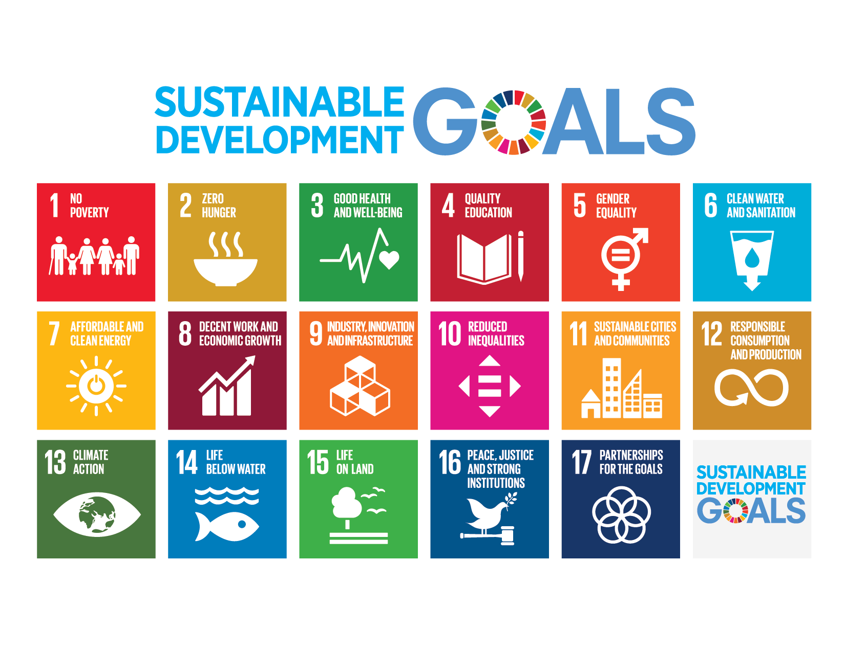

Figure 01; *SDG’s* by UN

## Challenges of Implementation

Primarily the most important challenge in the implementation of sustainable initiatives, like the development of infrastructure under the Goal of UN SDGs Corruption appeared as the major barrier. It was reported that Bangladesh possessed a high extent of corruption in the context of the Garments Industry leading to some major accidents. In the Savar Tragedy the evacuation was announced before the collapse, however, the factory owners having tenders of Mango, Primark and Wal-Mart ignored the warning under the element of corruption that resulted in tragedy. In addition to this absolute poverty is also recognized as one of the key barriers under which the process of sustainable initiatives halted (Rashid, 2020). The population belonging to extensive poverty agreed towards the below-average wage offered by the factory owners that bring the overall wages down for the garment factory employee. The UN SDG of eradicating poverty also compromised under this challenge (Ansar, 2021). Besides this the other challenges included; political agenda, and slow economic growth that developed problems for sustainable development initiatives in this sector (Stanwick and Stanwick, 2015). Hence these areas required extensive and rapid attention for betterment.

# Understanding of the Effects of Sustainability on Supply Chains in the Apparel Industry

## Overview to Supply Chain and Sustainable Procurement

The supply chain is one of the key aspects of the business industry and is defined as; “the network of all the individuals, organizations, resources, activities and technology involved in the creation and sale of a product” (Frederico et al., 2019). The supply chain possessed multiple points and operations within a single term of processing. The process of the supply chain covered every aspect of the business operations that range from the sourcing of the material from the major suppliers followed by the manufacturing units leading towards the delivery to the actual consumer or end user. The importance of supply chain and effective supply chain management is evident and significant it was highlighted that effective supply chain management played a key role in the achievement of various business objectives including the core of sustainability (Almomoni, 2021). Hence the importance possessed by the Supply chain is evident in every type of business industry.

Sustainable procurement is one of the key concepts of Supply Chain Management (SCM) that is associated with the aspect of sustainability within the cores of the supply chain through the integration of the Corporate Social Responsibility Cores. Sustainable procurement is referred to as; “Sustainable procurement is the integration of Corporate Social Responsibility (CSR) principles into your company's procurement processes and decisions while ensuring they still meet the requirements of your stakeholders” (Kannan, 2021). Sustainable procurement is very important because it played a key role in the development of overall brand reputation in the business environment while critically associated with limiting overall sustainability issues like Human Rights violations observed in the case of the Bangladesh Garment Industry. Additionally, this aspect also highlighted the weaknesses of the suppliers while elaborating on the areas in the supply chain that could lead towards defamation and public scandals (Laosirihongthong, 2019). Hence the brand reputation among the public is majorly affected by the aspect of Sustainable Procurement within SCM.

## Supply Chain Team Responsibilities- Fashion Firm Sector

In the financial year of 2018, the fashion sector of the world was associated with the emission of GHG with the value of 2.1 Billion metric tons and the majority of this emission developed under the aspect of Fast Fashion. In recent years the supply chain teams of the fast fashion leaders like H&M, and ZARA adopted the cores of sustainable initiatives that developed on the grounds of Sustainable Supply Chain Management (SSCM) (Moretto et al., 2018). The SSCM is highlighted as the major responsibility among the supply chain teams of the fast fashion apparel sector. In the context of human rights violations observed in the Garments Industry of Bangladesh the major responsibility of the supply chain teams of some leading fast fashion brands (Stanwick and Stanwick, 2015). The aspect of ethical sourcing is very important in catering for the human rights violation type sustainable issues in the global business phenomenon.

### Ethical Sourcing Strategy

In the conventional era, the apparel and fashion industry were based on the fact that commercial success in the consumer market was primarily associated with the timing of apparel introduction in the market followed by the quality of the product. However, in the modern era, human rights violation issues played a key role in the success of the business followed by the development of the brand image (Van den Brink et al., 2019). Under this modern modification, the aspect of ethical sourcing became an important strategic move for the apparel sector (Figure 02). Besides this, some of the textile and apparel brands developed the fact that ethical sourcing strategies are associated with higher production costs that lead towards a decrease in profit margins and an increase in product prices. However, some profound research studies highlighted the fact the consumers in the market in actually ready to pay more prices for the product that are reached through the channel of SSCM initiatives like ethical sourcing (Koep et al., 2021). This aspect was developed among the consumers by the increase in awareness about gender inequality, low wages and unsafe working conditions for the employees. Moreover, in the apparel sector, the major prospect of ethical sourcing was the development of a supplier code of conduct, which covered the ethical standards and served as the documented for all the associated suppliers of the particular fashion brand. The suppliers failed to meet the requirement of this standard and developed the aspect of losing orders under the domain of guidelines violations (Cheng et al., 2018). With the aid of ethical sourcing, many brands contributed towards the eradication of human rights violation in the garments sector in the region of Bangladesh.

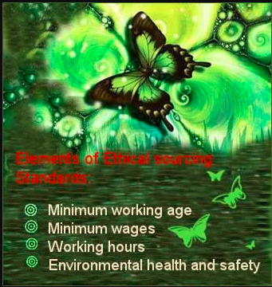

Figure 02; *Standards of Ethical Sourcing*

## H&M- Stood Against Human Rights Violations in Bangladesh

H&M is one of the famous fast fashion brands across the globe and the name of H&M is associated with the high fashion cloth with an affordable pricing model. The philosophy of H&M is; “to make trendy clothing affordable for everyone, and as a result, the brand manufactures clothing at an extraordinary speed, making it one of the biggest fast fashion brands in the world”. Despite the fast fashion, H&M adopted the transparent and effective SSCM for catering for the sustainability issues in the industry (López et al., 2022). Back in 2012, H&M approached the other suppliers with the idea of developing a democratic committee, and the primary purpose of this was to negotiate with the garment factory owner about better wages and safe working conditions for the workers in Bangladesh, to carry on the business relationship. Besides this for ensuring the quality of this SSCM initiative, the company made around 1000 visits to the garments factory of the manufacturers in a single year, and all of these visits were unannounced. The company made it clear that they carry on the business with the factories that were meeting the codes under SSCM for ethics (Stanwick and Stanwick, 2015). Hence H&M appeared as one of the global players that adopted the strategy of ethical sourcing, to safeguard the rights of the workers of the Garments Factory in Bangladesh.

# Sustainable Strategies to Improve the Working Conditions of the Garment Workers

## Strategies for Better Working Conditions

### Proper Ventilation System

The garments Factories of Bangladesh are heavily crowded with workers with poor infrastructure, especially in the context of ventilation. The workers in the garments factory are majorly exposed to the dust particles of Cotton during the operations of knitting, weaving and fabric cutting. It was reported that the handling of fabrics associated with the release of minute lint and other particles in the air ended up lungs of the workers developing many complications. The strategy of proper ventilation in the working spaces is highlighted as one of the key strategies in developing sustainability in business operations (Wan and Wang, 2018). Besides this, it was also revealed the majority of the garment factories provided no or sub-standard ventilation facility in the region of Bangladesh (Stanwick and Stanwick, 2015). Thus the strategy of effective ventilation possessed great potential in sustainability development followed by catering to sustainability issues in the Garments Factory of Bangladesh.

### Effective Sustainable Supply Chain Management

In the improvement of the working condition for the workers in the garment industry of Bangladesh, the effective utilization of Sustainable Supply Chain Management (SSCM) played a major role. It was observed and evident that SSCM initiatives from the companies like H&M, Walmart and Gap played a key role in developing the standards for the working conditions in the garments factory of Bangladesh (Stanwick and Stanwick, 2015). Besides this, the government also started paying attention to these cores of workers' better-working conditions. Despite this lapses needed to be covered for more enhanced implementation. The companies needed to engage the downstream and the upstream stakeholders in the SSCM strategies implementation. Along with that the fast fashion brands needed to develop the mechanism of incentives under the SSCM policies in the supply chain activities. The brand should also make long-term investments in factories working with effective sustainability standards in Bangladesh protecting human rights and offering reasonable wages to the worker without any aspect of gender discrimination (Wren, 2022). Hence these efforts from the brands possessed the ultimate potential in catering for the issues of workers working in the garments industry of Bangladesh.

## Sustainable Strategies under the Sight of Shared Values

The improvement in the working condition critically associated with the movement in productivity of the workers (Olofsson and Mark-Herbert, 2020). The improvement in efficiency is also related to the decline in production cost per merchandise, affecting the overall profit margins. The reports suggested the fact that the root causes of the lower productivity in the garments factory of Bangladesh were; poor management of the manufacturing units and workers and lower wages structure. Besides this the local factories in this region were reluctant towards the changes under the aspect of initial investments and probability in the outcomes, however, on the practical grounds, the implementation of the Sustainable Strategies possessed positive effects on the overall outcomes of the manufacturing facilities (Copeland and Bhaduri, 2019). Hence in the vision of shared values, the importance and affectivity of the strategies for catering the sustainability issues are regarded beneficial in a Holistic manner.

## Role of HR in Embedding Sustainability in Organizations

The role of HR is very prominent in developing and protecting the sustainability in the organizations (Macke and Genari, 2019). Some of the major roles of HR in this context were;

* Defining the Corporate Social Responsibility of the Company
* Regular Review of Sustainability Practices in the Working Mechanism
* Provision of Training to the Employees
* Enabling of Strategic Decision and Followed the Alignment
* Focusing and Catering Needs of the Employees

### Context of Fast Fashion Firms

In the context of Fast Fashion Firms, the role of HR is very prominent in ensuring and embedding sustainability within the organization (Ikram, 2022). Some of the key roles are;

* Helping Organizations in reaching goals with sustainability
* Improving and Employing the skills of the workforce in an efficient manner
* Increasing job satisfaction for employees and extracting enhanced productivity
* Effective communication with suppliers and other departments

# Leadership and Sustainability after the Rana Plaza Tragedy

The role of leader is very prominent in every sort of business organization. Without effective leadership, the achievement of sustainable development is very difficult for the business organization, as leadership is critically important in developing a positive relationship between employees and the company (Pauceanu et al., 2021). It was highlighted in the literature that; “Effective leadership translates into prudent public policy formulation and implementation, as well as good public service delivery, to meet the needs and aspirations of citizens”. The achievement of the SDGs also required support from the leadership of the company followed by society and government (Iqbal and Ahmad, 2021). Hence the role of leadership is very important in rising from the reputational damaging incidents like the “Rana Plaza”.

## Strategies by Primark after the Massacre

Primark’s leadership adopted multiple ways of dealing with image damage that occurred after the incident at Rana Plaza. The head of Primark’s Ethical Trade and Environmental Sustainability, Mr Paul Lister stated that; “Five years on from the Rana Plaza building collapse in Bangladesh, Primark continues to support those who were affected and over the period has contributed a total of over $14 million in aid and compensation. In June 2017 Primark signed the 2018 Transition Accord, reaffirming Primark’s commitment to collaborate with other brands, factory owners, NGOs, trade unions and the Government of Bangladesh to bring about sustainable positive change in the Bangladeshi garment industry” (Support provided by Primark since the Rana Plaza building collapse in Bangladesh). One of the key strategies for restoring the image of the brand followed by avoiding any kind of incident on the future grounds, Primark initiated their programme for “structural building inspections”, in the context of analyzing the supplier's factories working against the international standards. The inspection was carried out by the structural engineers and each of the factories in Bangladesh that were manufacturing goods for Primark was inspected with precision. Under this inspection, the CEO of the company hired a team of “Chartered Structural Engineers” for the smooth operations of this program. The teams inspected the entire factory and guide the factory owner for bringing betterment (Cook, 2018). This strategy adopted by the leadership of Primark played a vital role in restoring the image of Primark as a global apparent brand with a sense of CSR.

## Recommendations

The leadership of Primark and any other apparel industry must form collaborations with the government bodies of Bangladesh to support the Victims of the Rana Plaza incident, for boosting the image of the company followed by fulfilling ethical responsibilities. One of the companies Benetton Group launches this sort of program with “the Bangladesh-based nongovernmental organization BRAC” under the orders of the CEO, supporting the families of victims (Corbera, 2020). This aspect played a key role in restoring the good image of the brand among the consumers.

The CEOs of the company are also required to initiate programs for transparent audits of manufacturing facilities in other parts of the world not limited to Bangladesh. The clear audit of the major companies played a key role in highlighting the elements of corruption in the local factories. It was highlighted that the element of corruption played a major role in halting the process of sustainability initiatives in the garment sector of Bangladesh (Stanwick and Stanwick, 2015). Thus transparency holds great potential in the context of leadership strategies.

# References

Adams, C.A. and Larrinaga, C., 2019. Progress: engaging with organisations in pursuit of improved sustainability accounting and performance. *Accounting, Auditing & Accountability Journal*.

Almomoni, M.A., 2021. The importance of supply chain management in achieving competitive advantage: A theoretical study. *Journal of Social Sciences (COES&RJ-JSS)*, *10*(2), pp.194-207.

Ansar, A., 2021. From solidarity to resistance: host communities’ evolving response to the Rohingya refugees in Bangladesh. *Journal of International Humanitarian Action*, *6*(1), pp.1-14.

Cheng, P., Fu, Y. and Lai, K.K., 2018. Supply Chain Risk Management in the Apparel Industry. Routledge.

Cook, I., 2018. Inviting construction: Primark, Rana Plaza and Political LEGO. *Transactions of the Institute of British Geographers*, *43*(3), pp.477-495.

Copeland, L. and Bhaduri, G., 2019. Consumer relationship with pro-environmental apparel brands: effect of knowledge, skepticism and brand familiarity. *Journal of Product & Brand Management*.

Corbera, G., 2020. The Right to Garment: Crisis and Corporate Social Responsibility in the Rana Plaza Factory Collapse ‘13. In *Management and Inter/Intra Organizational Relationships in the Textile and Apparel Industry* (pp. 348-367). IGI Global.

Frederico, G.F., Garza-Reyes, J.A., Anosike, A. and Kumar, V., 2019. Supply Chain 4.0: concepts, maturity and research agenda. *Supply Chain Management: An International Journal*.

Garren, S.J. and Brinkmann, R., 2018. Sustainability definitions, historical context, and frameworks. In *The Palgrave handbook of sustainability* (pp. 1-18). Palgrave Macmillan, Cham.

Ikram, M., 2022. Transition toward green economy: Technological Innovation’s role in the fashion industry. *Current Opinion in Green and Sustainable Chemistry*, p.100657.

Iqbal, Q. and Ahmad, N.H., 2021. Sustainable development: The colors of sustainable leadership in learning organization. *Sustainable Development*, *29*(1), pp.108-119.

Kannan, D., 2021. Sustainable procurement drivers for extended multi-tier context: A multi-theoretical perspective in the Danish supply chain. *Transportation Research Part E: Logistics and Transportation Review*, *146*, p.102092.

Khan, Z., 2018. Transnational labour governance: A critical review of proposals for linkage through the lens of the Rana Plaza collapse in Bangladesh. *Canadian Journal of Law and Society/La Revue Canadienne Droit et Société*, *33*(2), pp.177-197.

Koep, L., Morris, J., Dembski, N. and Guenther, E., 2021. Buying Practices in the Textile and Fashion Industry: Past, Present and Future. In *Sustainable Textile and Fashion Value Chains* (pp. 55-73). Springer, Cham.

Laosirihongthong, T., Samaranayake, P. and Nagalingam, S., 2019. A holistic approach to supplier evaluation and order allocation towards sustainable procurement. *Benchmarking: An International Journal*.

López, T., Riedler, T., Köhnen, H. and Fütterer, M., 2022. Digital value chain restructuring and labour process transformations in the fast‐fashion sector: Evidence from the value chains of Zara & H&M. *Global Networks*, *22*(4), pp.684-700.

Lorincová, S., Štarchoň, P., Weberova, D., Hitka, M. and Lipoldová, M., 2019. Employee motivation as a tool to achieve sustainability of business processes. *Sustainability*, *11*(13), p.3509.

Macke, J. and Genari, D., 2019. Systematic literature review on sustainable human resource management. *Journal of cleaner production*, *208*, pp.806-815.

Mia, S. and Akter, M., 2019. Ready-Made Garments Sector of Bangladesh: Its Growth, Contribution and Challenges. *Economics*, *7*(1), pp.17-26.

Moretto, A., Macchion, L., Lion, A., Caniato, F., Danese, P. and Vinelli, A., 2018. Designing a roadmap towards a sustainable supply chain: A focus on the fashion industry. *Journal of cleaner production*, *193*, pp.169-184.

Olofsson, L. and Mark-Herbert, C., 2020. Creating shared values by integrating un sustainable development goals in corporate communication—the case of apparel retail. *Sustainability*, *12*(21), p.8806.

Pauceanu, A.M., Rabie, N., Moustafa, A. and Jiroveanu, D.C., 2021. Entrepreneurial leadership and sustainable development—A systematic literature review. *Sustainability*, *13*(21), p.11695.

Pizzi, S., Caputo, A., Corvino, A. and Venturelli, A., 2020. Management research and the UN sustainable development goals (SDGs): A bibliometric investigation and systematic review. *Journal of cleaner production*, *276*, p.124033.

Rashid, A., 2020. Corporate social responsibility reporting: meeting stakeholders expectations or efficient allocation of resources?. *International Journal of Accounting & Information Management*.

Stanwick, P. and Stanwick, S. 2015. “The Garment Industry in Bangladesh: A Human Rights Challenge,” Journal of Business &amp; Economic Policy, Vol. 2, pp. 40–44. Available at: <https://doi.org/https://www.jbepnet.com/journals/Vol_2_No_4_December_2015/5.pdf>.

Support provided by Primark since the Rana Plaza building collapse in Bangladesh | Primark Cares (USA). Available at: https://corporate.primark.com/en-us/newsroom/corporate-news/support-provided-by-primark-since-the-rana-plaza-building-collapse-in-bangladesh/n/3a96c071-680f-49e4-a4b4-b228ee6d29ff#:~:text=Six%20weeks%20after%20the%20disaster,the%20structural%20engineering%20consultancy%20MCS. (Accessed: November 14, 2022).

Van den Brink, S., Kleijn, R., Tukker, A. and Huisman, J., 2019. Approaches to responsible sourcing in mineral supply chains. *Resources, Conservation and Recycling*, *145*, pp.389-398.

Wan, X. and Wang, F., 2018. Numerical analysis of cooling effect of hybrid cooling clothing incorporated with phase change material (PCM) packs and air ventilation fans. *International Journal of Heat and Mass Transfer*, *126*, pp.636-648.

Wren, B., 2022. Sustainable supply chain management in the fast fashion Industry: A comparative study of current efforts and best practices to address the climate crisis. *Cleaner Logistics and Supply Chain*, *4*, p.100032.